|  |  |
| --- | --- |
| NAME – SNEHA DARBARWAR | ROLL NO. – K017 |
| BATCH – CSE CYBERSECURITY | DIV – K |
| DATE OF EXP -14-11-24 | DATE OF SUB – 14-11-24 |

**EXPERIMENT – 10**

**1) Write a program and demonstrate all components of angular.js**

i) <!DOCTYPE html>

<html lang="en-US">

<script src="https://ajax.googleapis.com/ajax/libs/angularjs/1.6.9/angular.min.js"></script>

<body>

    <div ng-app="">

        <p>Name : <input type="text" ng-model="name"></p>

        <h1>Hello {{name}}</h1>

    </div>

</body>

</html>

OUTPUT:

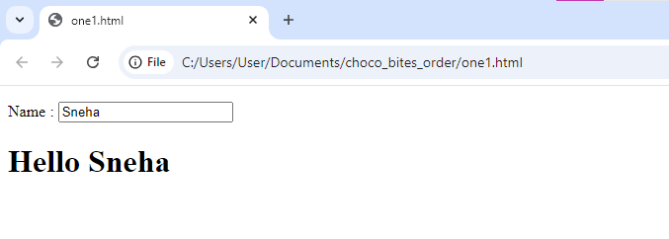

II) <!DOCTYPE html>

<html>

<head>

    <script src= "https://ajax.googleapis.com/ajax/libs/angularjs/1.6.9/angular.min.js"></script>

    <title>AngularJS Expression</title>

</head>

<body style="text-align:center">

    <h1 style="color:green">GeeksforGeeks</h1>

    <h3>AngularJS Expressions</h3>

    <div ng-app="" ng-init="name='GeeksforGeeks'">

        <p> {{ name }} is a portal for geeks.</p>

    </div>

</body>

</html>

OUTPUT:

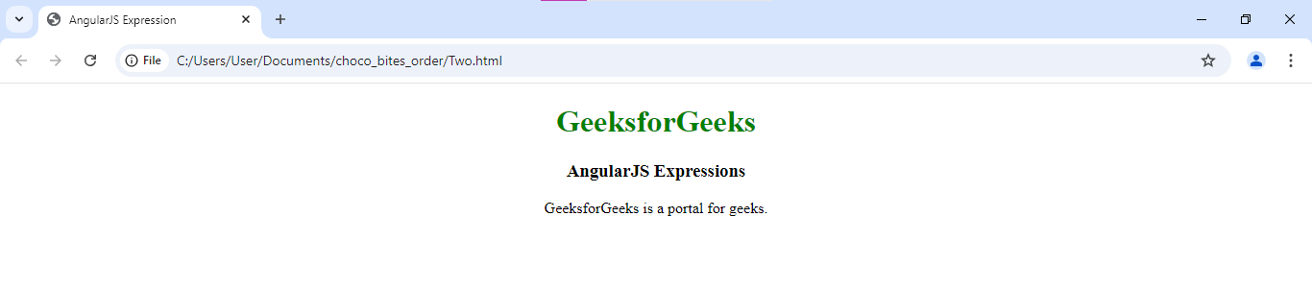

III) <!DOCTYPE html>

<html>

<head>

    <script src= "https://ajax.googleapis.com/ajax/libs/angularjs/1.6.9/angular.min.js"> </script>

    <title>AngularJS Expression</title>

</head>

<body>

    <h1 style="color:green"> GeeksforGeeks </h1>

    <h3>AngularJS Expressions</h3>

    <div ng-app="" ng-init="sort={one:'quick sort', two:'merge sort', three:'bubble sort'}">

        <p> Sorting Algorithms: <ul> <li>{{ sort.one }}</li>

            <li>{{ sort.two }}</li>

            <li>{{ sort.three }}</li></ul></p>

        </div>

</body>

</html>

OUTPUT:

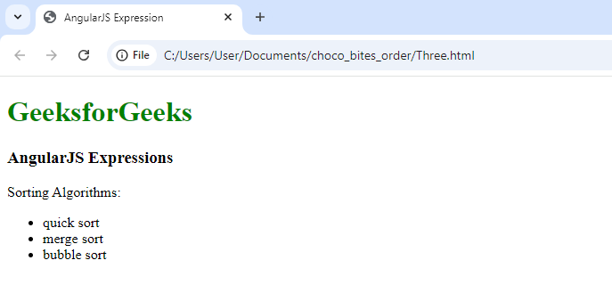

IV) <!DOCTYPE html>

<html>

<head>

    <title> Modules and Controllers in Files </title>

    <script src= "https://ajax.googleapis.com/ajax/libs/angularjs/1.6.9/angular.min.js"> </script>

</head>

<body>

    <div ng-app="GFG" w3-test-directive></div>

    <script>

    var gfg_app = angular.module("GFG", []);

    gfg_app.directive("w3TestDirective", function() {return { template : "Welcome to GeeksforGeeks!"}; });

    </script>

</body>

</html>

OUTPUT:

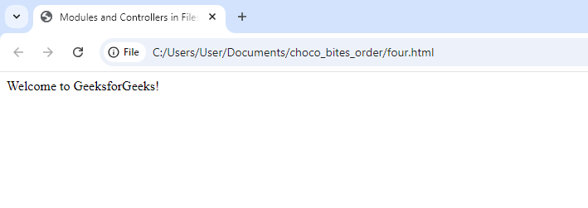

V) <!DOCTYPE html>

<html>

<script src="https://ajax.googleapis.com/ajax/libs/angularjs/1.6.9/angular.min.js"></script>

<body>

<div ng-app="myApp" ng-controller="myCtrl">

<ul>

  <li ng-repeat="x in names">{{x}}</li>

</ul>

</div>

<script>

var app = angular.module('myApp', []);

app.controller('myCtrl', function($scope) {

    $scope.names = ["SNEHA", "NAIN", "SAHASRA"];

});

</script>

<p>The variable "x" has a different value for each repetition, proving that each repetition has its own scope.</p>

</body>

</html>

OUTPUT:

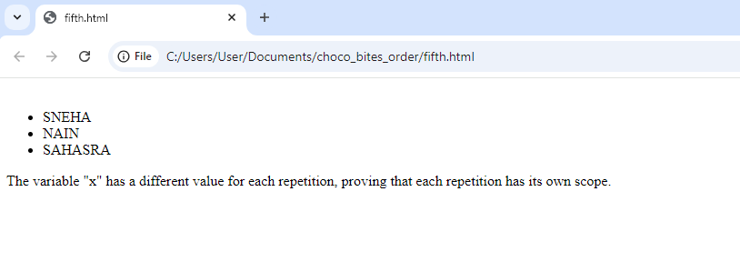

VI) <!DOCTYPE html>

<html xmlns="http://www.w3.org/1999/xhtml">

<head>

    <title></title>

    <script src="Scripts/angular.min.js"></script>

    <script src="Scripts/Script.js"></script>

    <link href="Styles.css" rel="stylesheet" />

</head>

<body ng-app="myModule">

    <div ng-controller="myController">

<table>

            <thead>

                <tr>

                    <th ng-click="sortData('name')">

                        Name <div ng-class="getSortClass('name')"></div>

                    </th>

<th ng-click="sortData('dateOfBirth')">

                        Date of Birth <div ng-class="getSortClass('dateOfBirth')"></div>

                    </th>

                    <th ng-click="sortData('gender')">

                        Gender <div ng-class="getSortClass('gender')"></div>

                    </th>

                    <th ng-click="sortData('salary')">

                        Salary <div ng-class="getSortClass('salary')"></div>

                    </th>

                </tr>

            </thead>

            <tbody>

<tr ng-repeat="employee in employees | orderBy:sortColumn:reverseSort">

                    <td> {{ employee.name }} </td>

                    <td> {{ employee.dateOfBirth | date:"dd/MM/yyyy" }} </td>

                    <td> {{ employee.gender }} </td>

                    <td> {{ employee.salary  }} </td>

                </tr>

            </tbody>

        </table>

    </div>

</body>

</html>

OUTPUT:

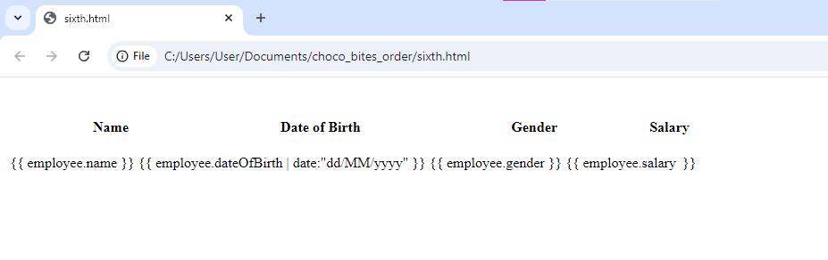

**CONCLUSION**: in this experiment we learned how angular js works and how to execute it using html.